TASK

Installation of Docker:

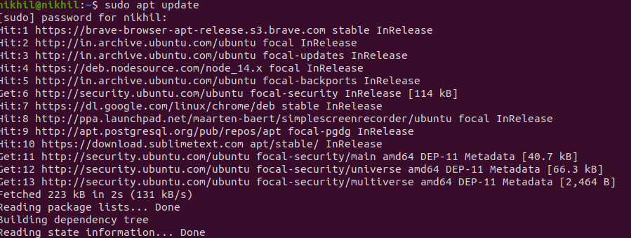

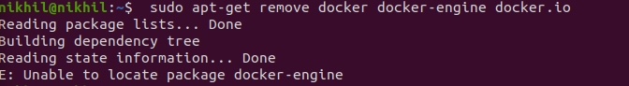

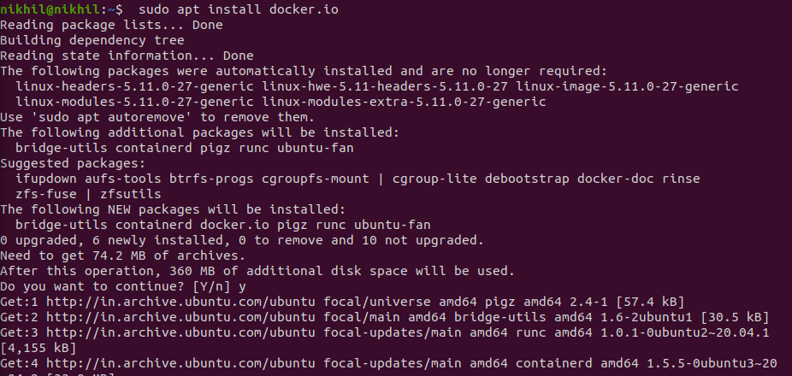

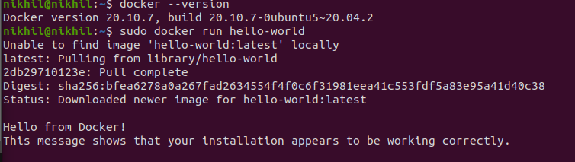

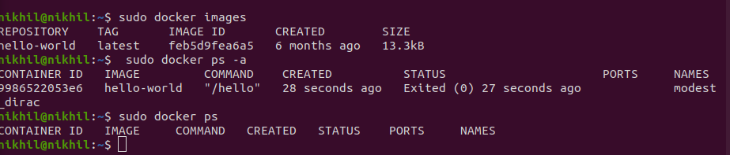

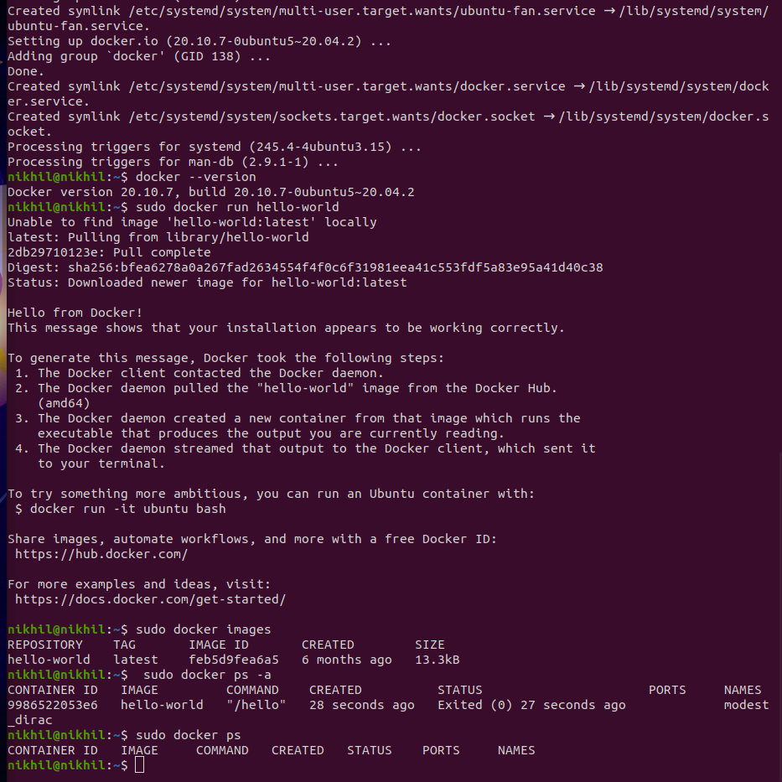

And Build spring boot application

>> So first install sample spring boot application

>> Install maven in that application

>> it will create one folder which all dependencies perform

>> Then we run the particular application cmd

Java -jar application name

>> now run in local host

